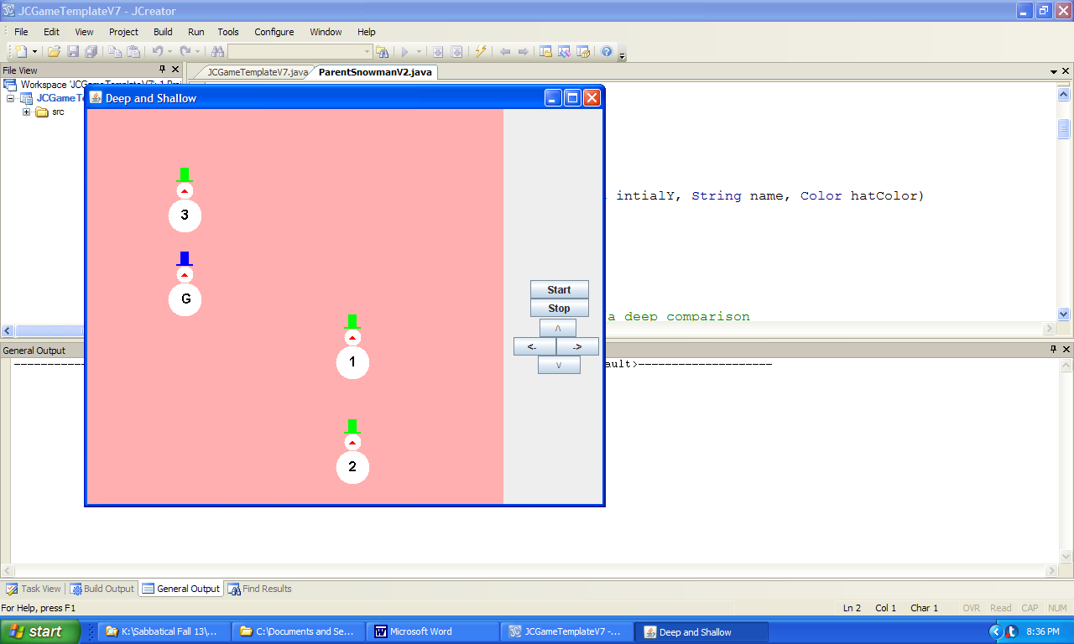 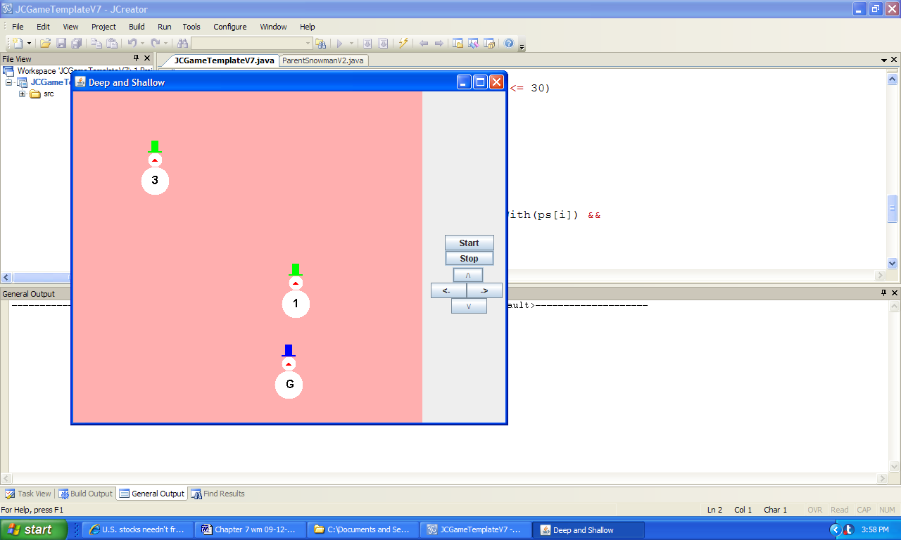

a) Game board when the program is launched b) Game board after green-hat snowman 2 is found

and placed behind the guard

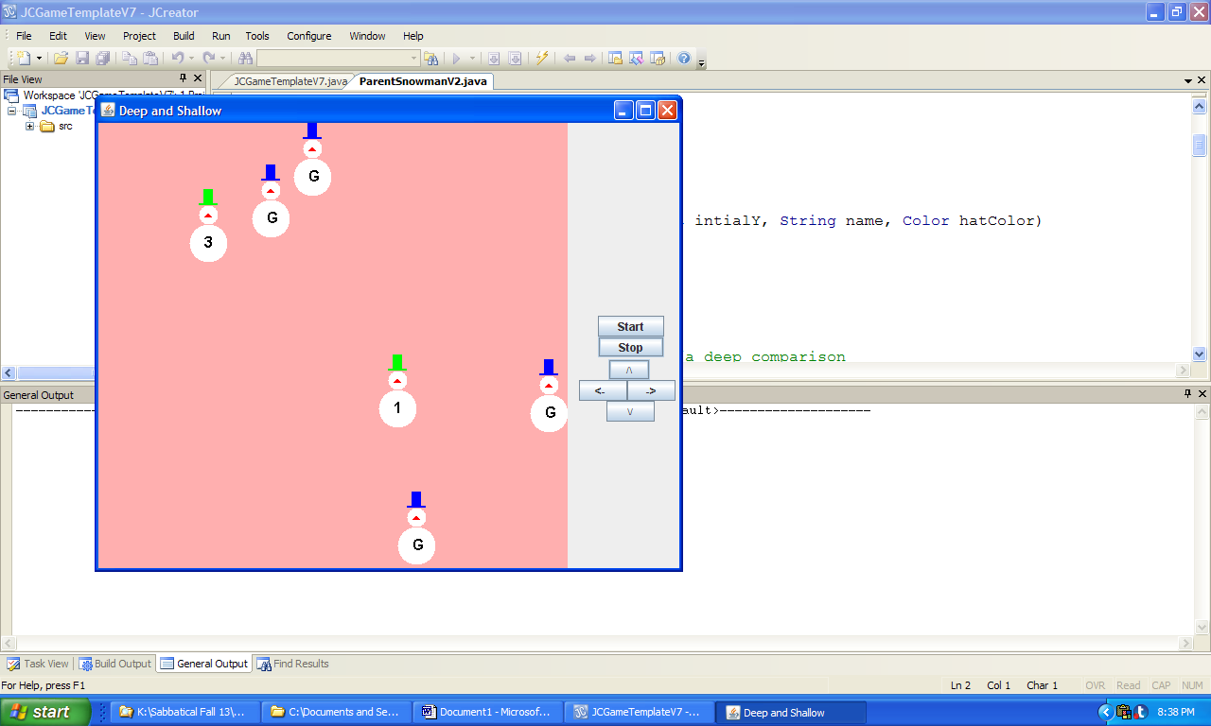 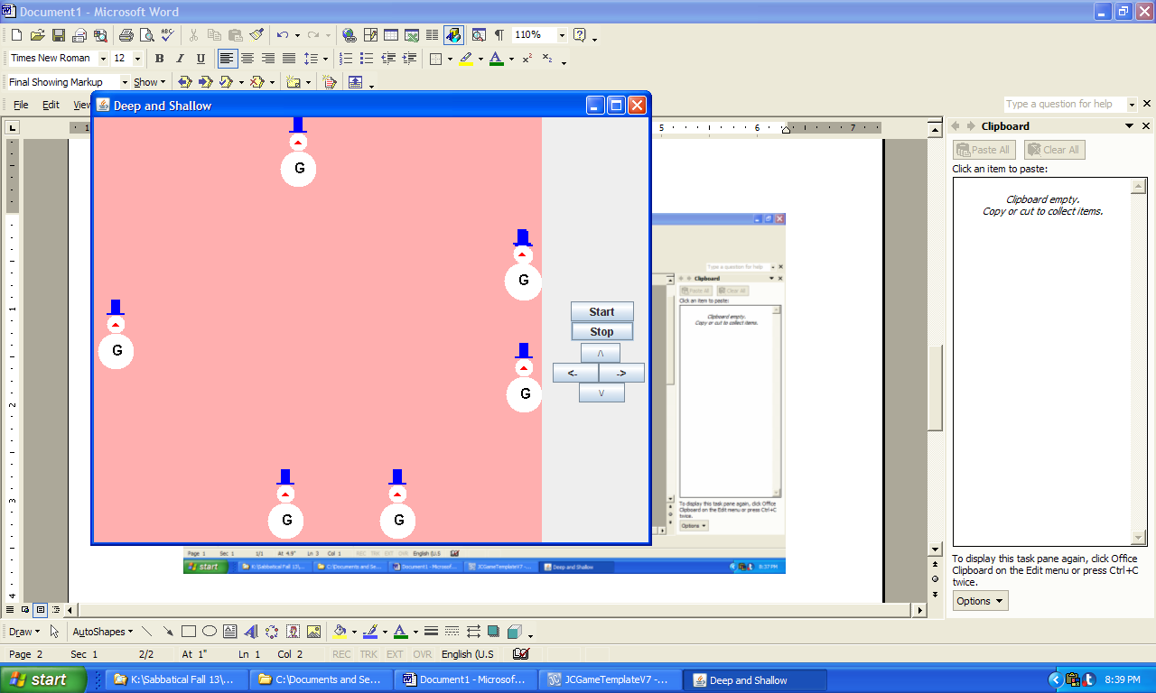

c) Game board after three clones are posted d) Game board after six clones have been posted

and green-hat snowman 3 is about to be found and all the wonderers have been found

**Figure 7.14 Graphical output produced by the application DeepAndShallow.**